STATE OF NEVADA  Adult and Youth Sports COVID-19 Preparedness & Safety Plan  DEPARTMENT OF BUSINESS AND INDUSTRY CHECKLIST  https://nvhealthresponse.nv.gov/ | 

Instructions:
A COVID-19 Preparedness & Safety Plan is required for adult and youth sports leagues:
- The Sports Safety Plan must include all the baseline requirements, protocols, restrictions and operating rules set forth in the Nevada Guidance for Adult and Youth Sports to ensure that, among other requirements: (i) the number of spectators and participants admitted to the premises at any given time does not violate the capacity limits set forth in Governor’s Directive 033.
This checklist will help sports leagues prepare for successful competitions and draft specific operational plans. This checklist is not intended to fully inform you of every provision regarding COVID-19 prevention and mitigation. It is your responsibility to take all necessary factors into account. The plan and any supporting documents must fully address all elements on the list. Failure to address all items may result in your plan being delayed or disapproved.

General Information:
☐ Primary contact name(s) & contact information, including how they can be reached during and after games.
- Emily Spragno, President, Boulder City, NV 89005 (661) 675-5739
☐ League name, location & specific hours of operation (including set up and tear down)
- We operate out of Veterans Memorial Park at 1650 Buchanan Boulevard, Boulder City, NV 89005. Our hours of use are Monday through Thursday evenings from 3:00pm-10:000pm which includes setting up and tearing down. We have no planned weekend use for the fall of 2020.
☐ What signage will you post at gathering venue entrances outlining established protocols. Consider utilizing signage with easy to interpret graphics in commonly used languages reminding everyone to maintain 6 feet of distance, wear masks, wash hands, etc.
- Signage to be posted by our program will be in addition to that already in place issued by the City of Boulder City, the municipality who owns the property we utilize. This signage will reflect maximum capacity, social distancing mandates and face covering requirements.
☐ What instructions will be posted for individuals throughout the gathering venue at entrances that inform individuals of: capacity limits; prohibitions on entering a gathering if they are experiencing symptoms; hygiene and social distancing instructions, signage, and markings; and face covering requirements.
- Instructions shall be posted throughout the field, primarily at the check-in table, informing all participants, officials and spectators that out capacity limit, set by the City of Boulder City, is no more than 250 people per field.
- Instructions shall be posted throughout the field, primarily at the check-in table, prohibiting anyone experiencing symptoms, from participating in any way, with the scheduled events. We shall remind all users to practice safe hygiene and social distancing.
- Instructions shall be posted throughout the field, primarily at the check-in table, reminding all users that the use of face coverings is required. Face covering rules are enforced, along with all other requirements in this guidance. Teams, coaches and athletes are responsible for abiding by the rules and requirements set forth in this Preparedness and Safety Plan.
Capacity & Map for Practices and Competitions:
☐ Size of the venue in square feet and regular occupancy level
- See attached map for square footage. Max regular capacity is 800 persons
☐ Total number of attendees over the course of the event and maximum number of attendees at any one time
- Total number of attendees for course of the season would be roughly 800 over two months. Max at any one time would be limited to 250 persons or less, following current guidelines.
☐ Discuss how compliance with the maximum number of attendees will be achieved.
- Compliance with the site maximum will be achieved by requiring a field monitor to count the number of attendees
☐ Discuss how the planned maximum number of attendees will be enforced.
- In order to ensure the maximum number of attendees is enforced, parents and spectators will be asked to wait in their vehicles until all previous attendees have vacated the premises. Games will be spaces 30 minutes apart to allow this.
☐ Provide a map and/or plot plan of the venue that shows the following:
- See attached map
☐ Playing areas and benches | ☐ Traffic flow through event | ☐ Food service locations
☐ Toilet facilities | ☐ Screening station(s) | ☐ Areas for coaches, referees
☐ Handwashing/sanitizing stations | ☐ Isolation area | ☐ Spectator areas

Arrival and Exiting:
☐ Discuss how games and practices will be timed to allow at least a 30-minute break between the finish and start of subsequent sessions, to allow for departure and arrival without congestion.
- All games and practices will be timed to allow 30-minute breaks between the end of one session and the beginning of the next, to allow for departure and arrival without congestion of participants and spectators.
☐ Discuss procedures for players and coaches to minimize their arrival time prior to a game or practice session.
- Players and coaches may warm up in open field areas, where applicable, no more than 30 minutes before the start of their game. Parents and spectators must remain in their vehicles until all previous parents and spectators have departed.
☐ Discuss procedures to require teams and spectators to depart the field or facility immediately upon completion of the game or practice.
- Players and coaches will be asked to leave immediately at the conclusion of the game, unless they are participating in another game immediately following the first game. The field monitor will ensure compliance
☐ Discuss procedures for players to wait in their cars with guardians until just before the beginning of a practice, warm-up, or game, instead of forming a group.
- No congregating in the parking lot or open areas. Everyone must wear a face covering while arriving to and leaving the premises.

Sanitation Schedule Cleaning and Disinfection:
☐ Identify areas that need to be cleaned frequently, including shared equipment, restrooms, concession stands, high-touch items such as door handles, etc.
- Areas that must be cleaned by our staff between games include: dugout benches and any very limited shared equipment like baseballs (our players are required to provide all of their own gear).
☐ Identify how you will separate equipment that needs to be cleaned and disinfected before reusing.
- Baseballs used during play/practice will be placed in a separate bucket to be sanitized and disinfected before re-use. No other equipment is shared between players and/or coaches.
☐ Develop a schedule for cleaning and disinfecting the areas identified, including, at minimum, before and after each practice and game.
- Every shared surface/piece of equipment will be sanitized between games and after final game of the day.
☐ Identify who will be responsible for sanitizing each area identified.
- Equipment manager shall be responsible for sanitizing each item necessary.

☐ What sanitizers and/or disinfectants from the EPA "N" List are you using?
- 3M general disinfectant for baseballs, hard surfaces and restrooms https://multimedia.3m.com/mws/mediawebserver?mwsId=SSSSSuUn_zu8l00x4YtUN8_Bnv70k17zHvu9lxtD7SSSSSS--
- The required contact time for this product is 1 minute for human coronavirus. We shall have someone time the period that the surface remains wet and ensure that 1 minute is sufficiently met.
- Hand sanitizer provided on site will be the following (in 1 gallon containers): http://sds.betco.com/sds/BetcoSDS/776.pdf
- Hand sanitizer will be refilled as necessary, at minimum every 3 hours.
☐ What is the required contact time for the chosen product and how will you ensure this is met?
- Required contact time for the product above is 1 minute. The equipment manager shall make sure each surface remains wet for one minute by setting a timer and re-spraying as necessary depending on environment (like wind/heat/etc.)
☐ How will you ensure that jerseys, uniforms and other practice/game attire are washed after every use?
- Jerseys, uniforms and game attire shall be inspected upon arrival of players to make sure they are clean and laundered. Players will be sent home with uniforms that have not been washed.
☐ How will you ensure that participants pick up their own trash at the conclusion of all games, practices and activities. Extra trash bins should be provided, and more frequent disposal should occur. Where applicable, departing teams or league representative must sanitize the team/player area.
- As the parks we use are public parks and not maintained by our organization, the restrooms are cleaned by the municipality at minimum of daily, in the morning. The organization shall provide additional sanitizing every 90-120 minutes, or between games. This shall be done by a member of the board present at games, ideally the equipment manager
- For higher use facilities, or during times of greater use they shall be sanitized more frequently. We will ensure a one-in, one-out policy while we are in attendance.
Personal Hygiene:
☐ How will you ensure that staff and players practice healthy hygiene including washing their hands frequently and covering their sneezes and coughs?
- Staff and players MUST practice healthy hygiene and was their hands frequently. All sneezes and coughs must be covered. Hands must be sanitized immediately after.
☐ Where will hand sanitizer be placed, how often will it be checked for restocking and who will be responsible for restocking?
- Hand sanitizer will be available in the dugouts and outside of each dugout for spectators. It will be checked and restocked as often as necessary by the equipment manager. Minimum of every game
☐ How will you ensure that leagues, coaches, managers and trainers have supplies for event staff and participants available, including hand sanitizer that contains at least 60% alcohol, tissues, trash baskets, disposable facemasks, and disinfecting products.
- Our teams, coaches, managers and applicable volunteers will all have an equipment case containing hand sanitizer (min 60% alcohol), facial tissues, disposable face masks and the disinfecting product listed above. There are trash receptacles in the dugouts and throughout the facilities we will be using.

Use of Face Coverings and Personal Protective Equipment (PPE):
☐ How will you ensure that face coverings are worn properly by coaches, managers, sports staff, officials, parents/guardians, and allowed attendees and spectators? Players and athletes must also wear face coverings indoors and outdoors, except when: actively eating or drinking; or when actively exercising or participating in practices or competitions.
- We have trained all of our coaches, managers and staff have to wear a face covering at all times during practices and games. We will monitor for full compliance.
☐ Who will enforce that face coverings are worn properly for each game, practice or competition?
- The field monitor
☐ What signage will you have in place informing attendees, vendors and performers of the face covering requirements?
- Posters will be placed on an A-frame at any location that we are using (EXHIBIT B)
☐ What PPE will staff use for sanitizing?
- While sanitizing, the equipment manager will wear a disposable face mask and gloves.
- We will supply disposable face masks and gloves to any staff or volunteer that needs them.
☐ Do you have sufficient face coverings and PPE to distribute to staff and volunteers?
- Yes, we do.

Social Distancing:
☐ How will you ensure staff, attendees, and participants will remain at least 6 ft apart within the venue?
☐ Traffic arrows or guides | ☐ Queuing within venue | ☐ Barriers at vendor booths
☐ Scheduled entry | ☐ Posters | ☐ Other
☐ Restroom access/use | ☐ PA reminders | ☐
- Signage will be provided by both the municipality (in this case, City of Boulder City) and our organization mandating that all attendees, staff and participants remain 6 feet apart while not on the field of play (where applicable, baseball is a distanced sport by nature).
- We shall schedule entry by adding 30 minutes between games and asking that parents and spectators remain in their vehicles until game time.
- Restroom access will be monitored and limited to a one-in, one-out standard (with 6 foot makings to maintain the line).
- Posters will be placed on an A-frame at any location that we are using (EXHIBIT B)
- We will not be using a PA in a public venue, nor will we have vendors.
☐ How will you ensure that during times when players are not actively participating in practice or competition, that social distancing will be achieved by increasing space between players on the sideline, dugout, or bench?
- While our players are not actively participating, they will be distanced along the foul line fencing, 6 feet apart. Dugouts will be limited to an assistant coach, the batter on deck and the batter “in the hole” to maintain that 6 feet of distance required.
- During warm-ups, skill building and simulation drills, players are required to maintain their distance. This is relatively easy with a large field to space out on.
☐ How will you ensure that players are at least 6 feet apart on the field, when possible, while participating in the sport (such as during warmup, skill building activities and simulation drills)?
- Our players and coaches have become accustomed to what constitutes 6 feet after months of practices. They use the sections of fence as guidelines for 6 feet
☐ How will you create physical distance between players when explaining drills or the rules of the game?
- Our players and coaches have become accustomed to what constitutes 6 feet after months of practices. They use the sections of fence as guidelines for 6 feet
☐ How will you prohibit unnecessary physical contact, such as high fives, handshakes, fist bumps, or hugs?
- Players and staff have been actively prohibited from unnecessary physical contact since practices resumed in June. We will continue to discourage high fives, handshakes, fist bumps, etc.

☐ Where will the designated areas for managers and coaches, when not practicing/playing, to ensure physical distancing is maintained?
- Managers and coaches will not be on the field if they are not practicing or playing. Managers/coaches limited to a maximum of 3 persons and may occupy the dugout while players are only allowed in dugout if they are the on deck/in the hole batter (max occupancy 5 persons, with social distancing)
☐ Identify plans to limit the number of spectators admitted into the premises so that all staff, volunteers, contractors and spectators can keep six (6) feet of physical distance.
- Park monitor has a clicker to count persons entering and exiting.
☐ How will you encourage players not to travel with other members of the team and only members of their immediate households?
- Players will be encouraged not to carpool with members outside of their immediate household.
☐ How will you ensure players and spectators for sporting events do not share space, including but not limited to restrooms, hallways, concession stands?
- No members outside of the same household will be allowed to share space in any common areas such as restrooms, walkways or hallways.
- Restroom access will be monitored and limited to a one-in, one-out standard (with 6 foot makings to maintain the line).
☐ Who will be responsible for monitoring and enforcing social distancing requirements for players, managers, coaches and spectators?
- We will appoint a location monitor to ensure social distancing requirements for ALL participants. This includes players, managers, coaches and spectators.

Shared Equipment and Commonly Touched Surfaces:
☐ Which equipment will be shared vs. which equipment must be solely used by one player?
- The only shared equipment to be used by players are baseballs. All players are required to provide their own bat, helmet, glove, etc. to be kept with their equipment in their designated area.
☐ How will you ensure that when it is necessary to share critical or limited equipment, all surfaces of each piece of shared equipment are cleaned and disinfected frequently, as appropriate for the sport (e.g. between players, sets, periods, or games).
- Used baseballs shall be kept in a separate bucket to be cleaned by the equipment manager after each game.
☐ How will you ensure that players do not pick-up or touch another teams’ equipment when not necessary for play?
- Only the equipment manager shall handle any equipment (such as a bat) left after a player’s at bat.
☐ How will you require players or their family members to clean and disinfect equipment after each use?
- We will mandate that players clean and disinfect their own equipment after use.
☐ How will you ensure that players’ personal items and equipment are spaced out at least 6 feet apart?
- Each section of chain-link fence on a field is 6 feet long. Each player may occupy one section of fence with their equipment.
☐ How will you ensure players bring their own water/beverage to consume during and after games and practice?
- We will not provide any communal water or beverage sources. Players are reminded to bring hydration to every game and practice.
☐ How will you ensure there are no shared/communal snacks?
- We will not provide any communal snacks. Players are instructed to eat before or after games, snacks are not allowed on the field/in the dugout

☐ How will you require players to not spit or eat sunflower seeds, gum, or other similar products?
- Players are not allowed to spit, to eat sunflower seeds, gum or other similar products. Any players caught using those items will be asked to leave immediately.

Health Screenings, Isolation and Testing:
☐ How will you ensure and validate that adult coaches, managers, officials/referees and team staff have taken a COVID-19 test prior to the start of the season or resumption of athletic activity?
- We will require all adult managers, coaches, officials/umpires and team staff have signed an acknowledgement of their COVID-19 test prior to the start of the season/resumption of athletic competitions.
☐ If you are renting space from a local jurisdiction or private entity, discuss how you will provide verification of the results of the tests to that entity prior to commencement of any play.
- We will communicate that verification to any municipality (City of Boulder City) prior to the commencement of play.
☐ Who will perform contactless temperature screenings for all players/athletes, coaches, referees/officials, league officials, staff and managers before each practice, game or other team event?
- We shall designate location monitor to ensure provide contactless temperature screenings for all players/athletes, coaches, referees/officials, league officials, staff and managers before each practice, game or other team event.
☐ Who will collect COVID-19 screening surveys for all participants (coaches, managers, athletes/players, referees/officials, league officials, spectators/attendees, staff?) All participants MUST respond to COVID-19 screening-survey questions upon arrival and check-in at each practice, game or other team event. “NV COVID-19 Health Screening Guide” and the “COVID Screening Check In.”
- The monitor will collect COVID-19 screening surveys for all participants (coaches, managers, athletes/players, referees/officials, league officials, spectators/attendees, staff?) All participants MUST respond to COVID-19 screening-survey questions upon arrival and check-in at each practice, game or other team event. “NV COVID-19 Health Screening Guide” and the “COVID Screening Check In.” will be used (Exhibits C and D respectively).
- We also have an online questionnaire that we will require of ALL players, parents and coaches before they come to the venue: COVID Questionnaire.
☐ What will you do if someone on-site does not pass your screening requirements?
- If someone does not pass the screening requirement, they will be asked to leave the site immediately.
☐ What will you do if someone becomes ill with COVID-like symptoms on-site?
- If someone becomes ill with COVID-like symptoms on-site, they will be asked to leave immediately and/or emergency services will be called depending on the severity.
  - If necessary, games will be suspended and all participants will be asked to self-quarantine until further notice. Applicable entities will be notified.

Employee/Staff Training & Enforcement:
☐ How will you train staff on cleaning, sanitizing, and disinfecting?
- Staff will be trained on cleaning, sanitizing and disinfecting shared surfaces and baseballs. We will review the safety procedures with all applicable parties, but the equipment manager shall take the lead.
☐ If you will be using chemicals that are corrosive or flammable, what is your Hazard Communication program?
- We are not using corrosive or flammable materials.
☐ How will you train staff on face covering and PPE use?
- Staff has been trained on proper use of face coverings and PPE (gloves). Please see the following links to the CDC website used as a training reference:
  - Proper Use of Gloves
  - Proper Use of Face Masks
  - Social Distancing
  - General CDC Guidance on COVID-19
☐ How many staff/volunteers will you have to enforce capacity, social distancing and face covering requirements?
- We will have two staff per game (one per team) to enforce capacity, social distancing and face covering requirements.
☐ What will you do when a staff member, attendee, vendor, or participant does not comply with face covering, PPE or social distancing requirements?
- If any member does not want to comply with social distancing and face covering requirement, they will be asked to leave the premises immediately.
- All of our staff have a Southern Nevada Health District Food Handler Safety Card. In concessions only closed pre-packaged food shall be handled. All handlers should wear a mask and gloves at all times. Concessions will be thoroughly disinfected before and after each two hour (120 minute) shift. It will also be disinfected at the end of the evening.

Health Authority Approval:
☐ Provide a letter from the applicable local health authority confirming that the plan meets local health guidelines and will not place an unacceptable burden on the local health system. This must be submitted with all tournament plans.
- This is not a tournament plan

Submission Instructions:
- Plans must be submitted to the Department of Business and Industry 30 days prior to the event. Note that local jurisdictions may have other approval requirements that also need to be met.
- Phone: (702) 486-9000
- Email: COVID19Plans@dir.nv.gov

EXHIBIT A
Veterans Memorial Park has plenty of open grass. The capacity limit is in excess of 800 persons per the City of Boulder City Parks and Recreation Office. We will cap attendance at 250 or less, to allow for social distancing. Spectators must remain 6 feet from any fencing and from any players, plus room to walk to and from the restrooms. Isolation area is removed from the field of play and will only be used temporarily or in case of emergency. Anyone with symptoms will be asked to leave. Hand sanitizer will be provided by coaches for players and staff. Sanitizer stations shall be set up at the end of each spectator area between the bathroom and each respective side. There concession is also marked.

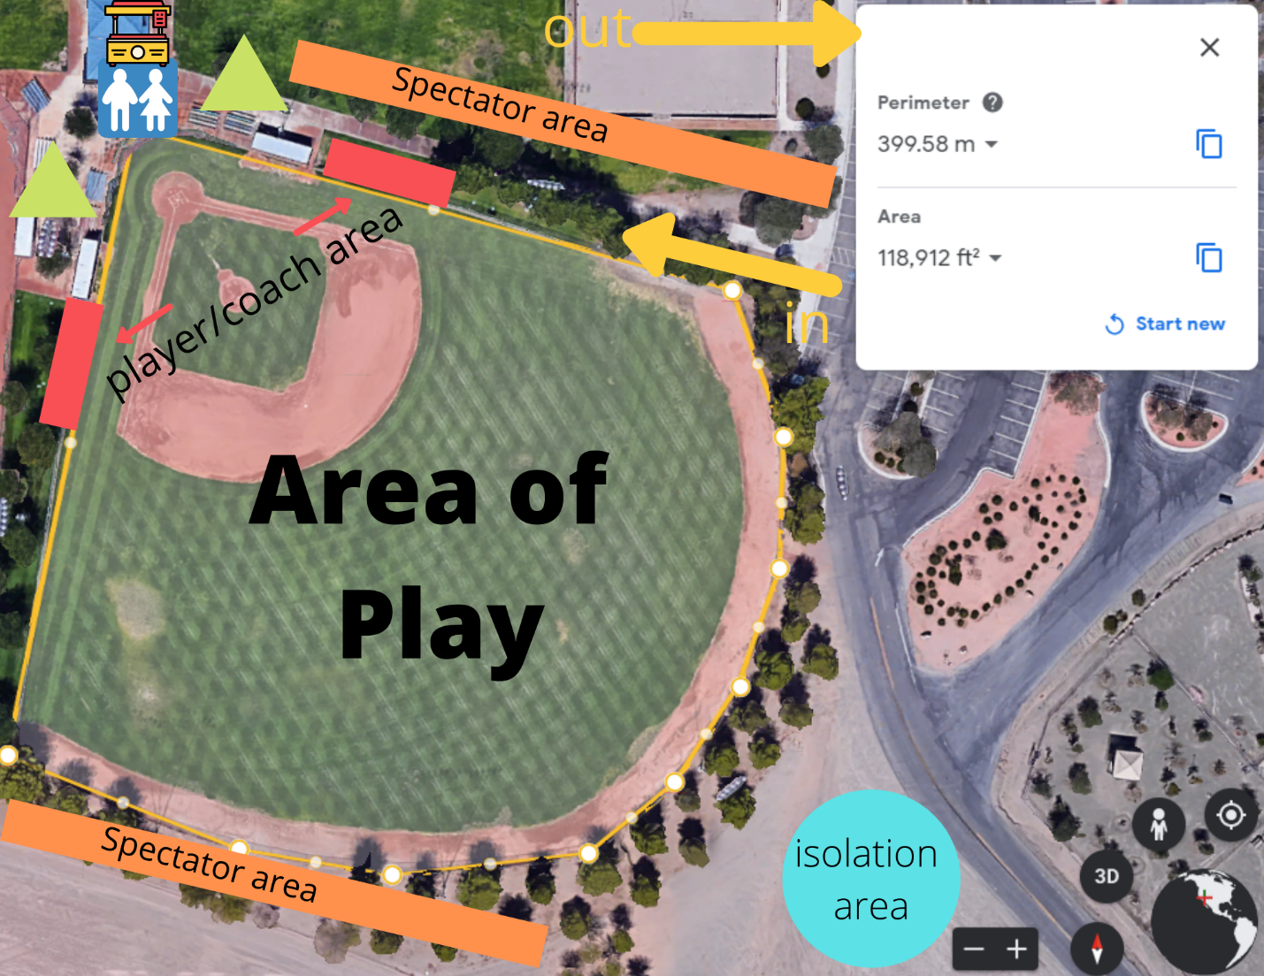

Exhibit B
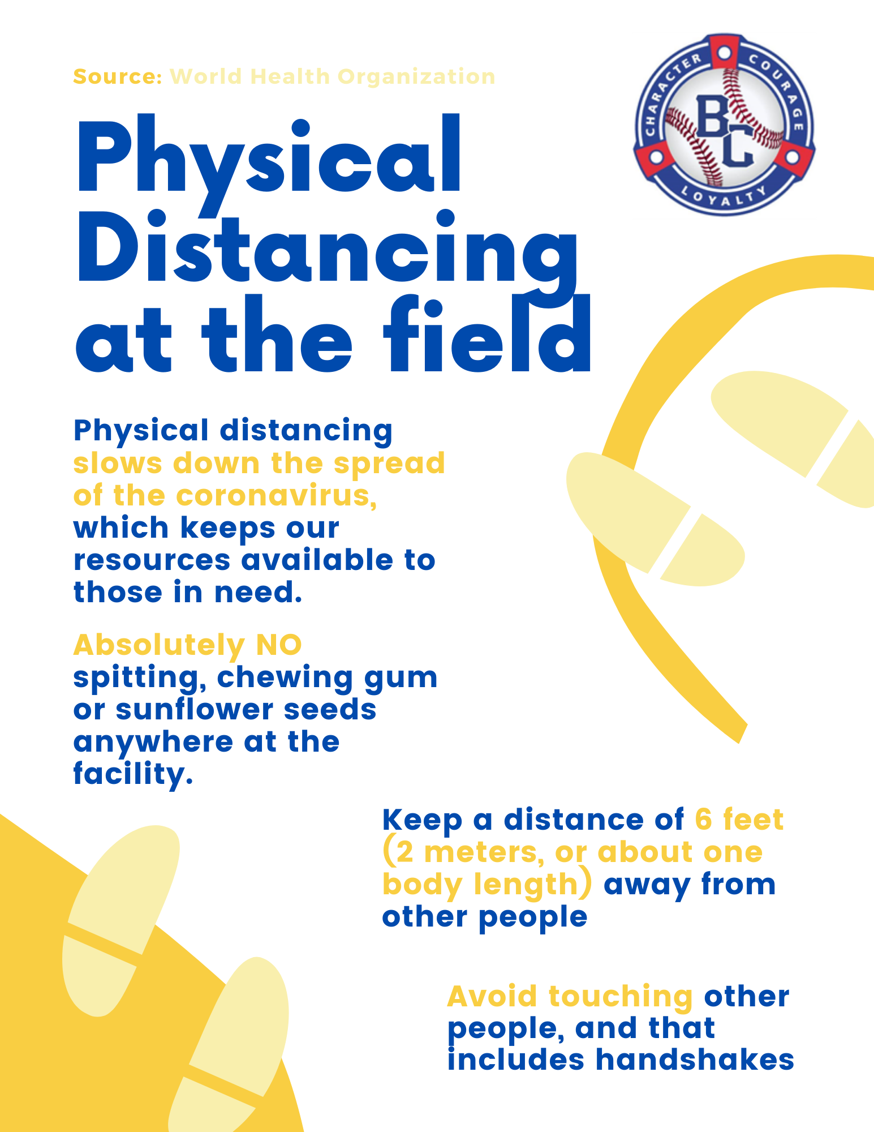

EXHIBIT C
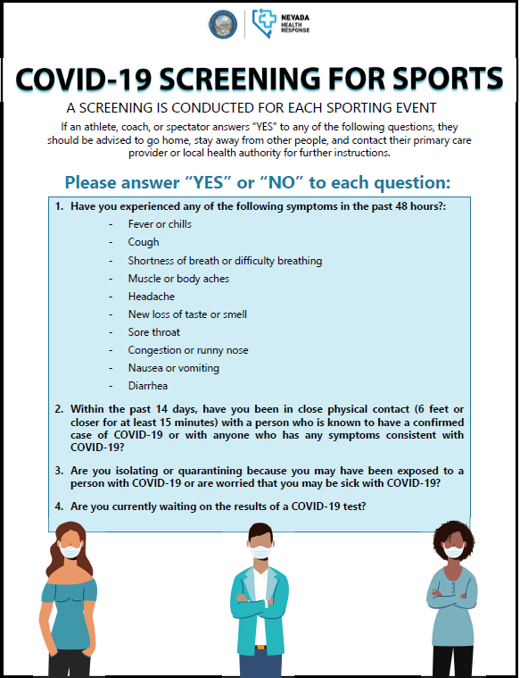

EXHIBIT D

